- February's drop in UK CPI inflation is likely to be the first of several chunky falls over the next few months, as large base effects come into play. With energy prices set to decline by 12% in April, we continue to expect inflation to drop back to the 2% target that month.
- Lower wholesale gas prices mean another large fall in the energy price cap is in prospect in July, so we expect inflation to fall further in the summer. However, inflation is likely to pick up again next year as the impact of falling energy prices fades.
CPI inflation slowed to 3.4% in February, down from 4% in January and the lowest rate since September 2021. February's drop was largely due to base effects, following large rises in food and services prices between January and February last year. As we anticipated, last month's downside surprise for services inflation, caused by the impact of the normal January fall in air fares being amplified by an increase in its weight, largely unwound in February. RPI and RPIX inflation fell to 4.5% and 3.5% respectively in February, from 4.9% and 3.8% in January.
Base effects will remain influential over the next couple of months, particularly in April due to the large price rises across a series of categories with inflation-linked contracts or regulated prices in that month last year. Ofgem has also confirmed that the energy price cap will fall by 12% in April, so we continue to expect CPI inflation to drop back to the 2% target that month.
Furthermore, though we're only a month into the new observation window, lower wholesale gas prices mean we are on track for another 8-10% fall in the energy price cap in July. So our forecast continues to show inflation dropping well below 2% in the second half of the year. However, we expect the downward pressures from falling energy prices to fade next year, which drags our forecast for headline inflation back above the 2% target again.

Chart 1: Inflation is forecast to drop below the 2% target in H2 2024
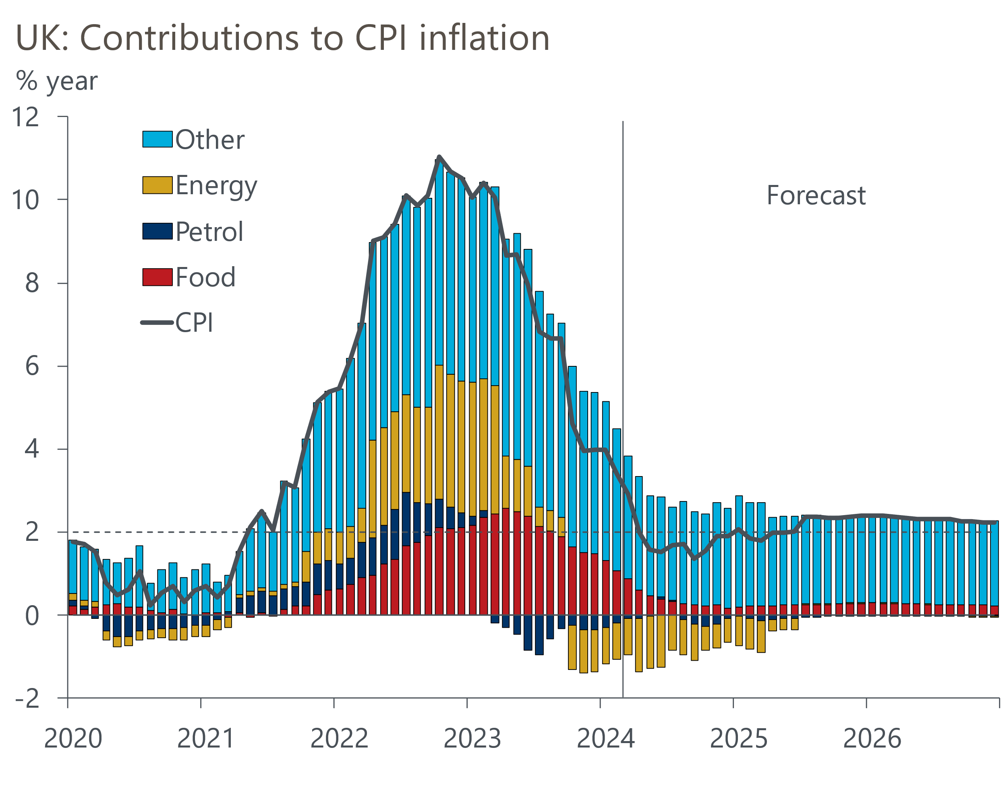
Source: Oxford Economics, Haver Analytics

